Questions

**Dr. Wang-I will ask one question from each category so there will be four questions in total for each person. If your answer to that question is not satisfying, I will give you a second question from the same category to make it up.**

Questions for exam:1) Pointer**- What is a pointer?**A variable that stores the memory address of another variable

**- What are meaning of those operators (*, &, ++) when they are associated with pointers: int *iptr, i;**This is dereferencing Iptr creating 1 new integer pointers named I

**\*ptr = 1;**sets the pointer = to 1

**&i**

Display the memory address of I, reference pointer

**iptr++**Moves the pointer forward one element

**- What is memory leak? What operations can cause memory leak?**A memory leak is a code operation that keeps eating up more and more memory without releasing it. It occurs when memory allocated by the programmer was not deallocated properly.

This can occur by dereferencing a pointer incorrectly

**2) OO concepts – inheritance and polymorphism, abstract function, virtual function, static binding, dynamic binding,**

**Inheritance**

A concept in which parent objects can have child objects in which they inherit some of their features, variables ,datatypes, and functions, very useful in things like game development when making multiple different enemy types

**Polymorphism**

Occurs when there is a hierarchy of classes that are related by inheritance, means that a call toa a member function will cause a different function to be executed depending on the type of object that invokes the function. Child object functions can overload parent functions

**Abstract function**

An abstract class is, conceptually, a class that cannot be instantiated and is usually implemented as a class that has one or more pure virtual (abstract) functions.

**Virtual function**

A virtual function is a member function which is declared within a base class and is re-defined(Overriden) by a derived class. Used to achieve runtime polymorphism

**Static binding**

The binding which can be resolved at compile time by compiler is known as static or early binding. Binding of all the static, private and final methods is done at compile-time .

**Dynamic binding**

In Dynamic binding compiler doesn’t decide the method to be called. Overriding is a perfect example of dynamic binding. In overriding both parent and child classes have same method .

3) Algorithms – use your own words to describe linearSearch, binarySearch, selectionSort, BubbleSort, mergeSort and explain their time complexity (you don’t have to go through the detailed model to derive the T(n), just some intuition to explain how you get the time complexity).

**Linear search**

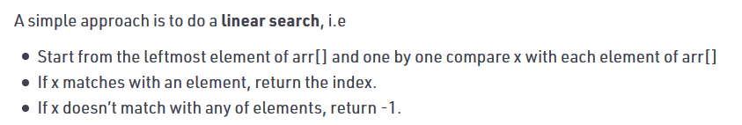

binarySearch

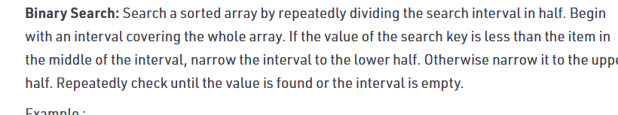

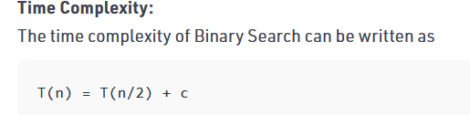

**selectionSort**

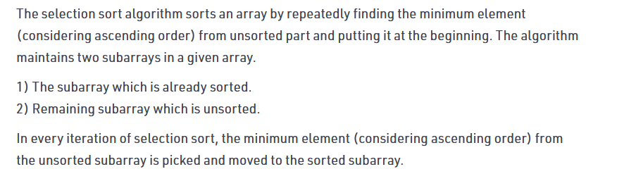

**BubbleSort**

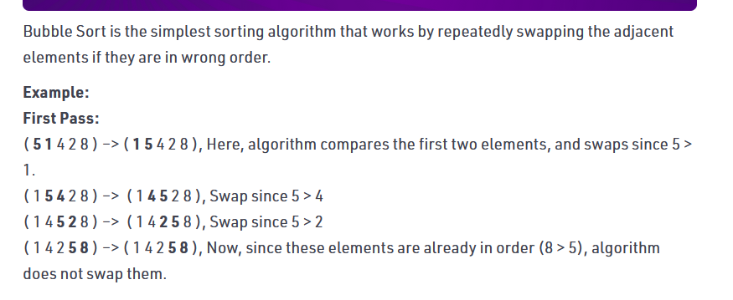

Very inefficient algortihim

**mergeSort-a divide and conquer algorithm**

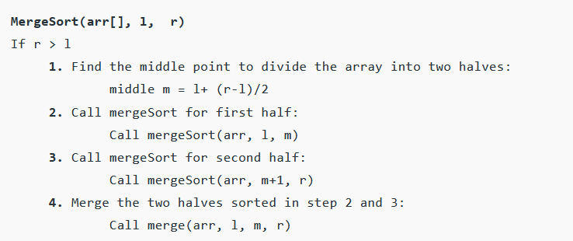

**4) Other concepts:- How Von neumman architecture works (the fetch-execute cycle)**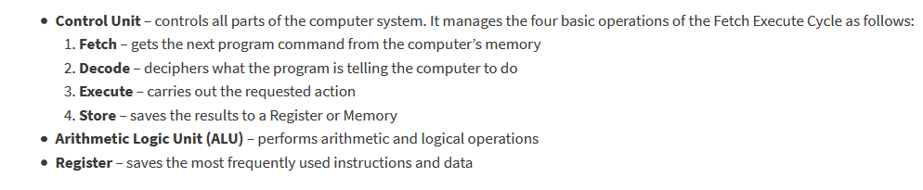

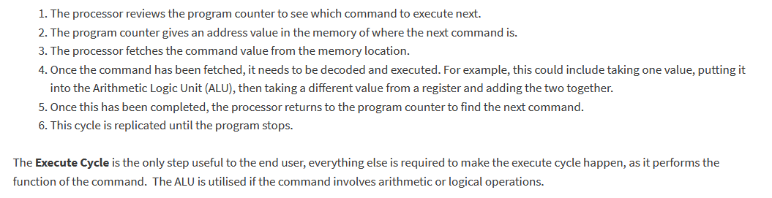

**- Stack overflow**An undesirable condition in which a computer program tries to use more memory space then the call stack has available , the call stack is a buffer that stores requests that need to be handled

Can be caused by excessively deep or infinite recursion

**- Constructors/destructors related questions (when do they get called? And the order they got called)**

Constructors are called when the object is initialized

Destructors are called when the program block /scope is finished, when the variable is reassigned or when it is deleted